Home Zone Map

(Please note – the binding definition of the home zone is the written description)
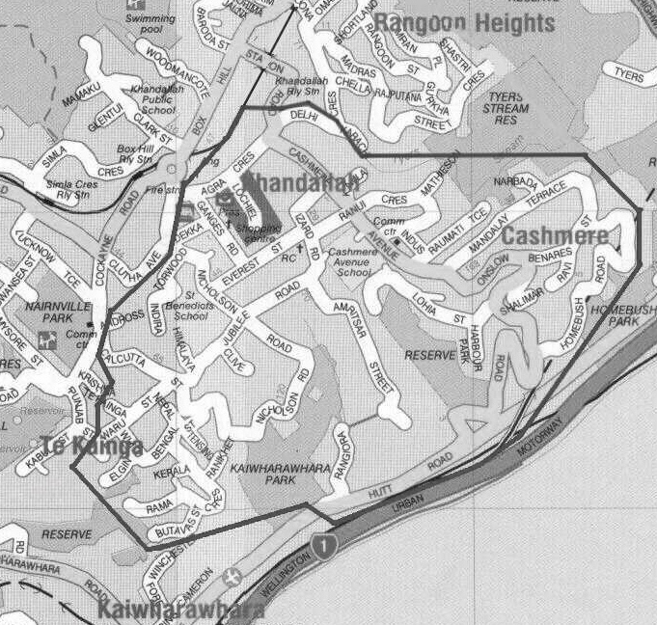

Approved, after review, by Cashmere Avenue School Board of Trustees
– 10 September 2007

110 Cashmere Avenue, Khandallah, Wellington.
Ph 04 939 4700 email: admin@cashmere-ave.school.nz
‘Equipping Learners to Explore & Thrive Together’

Cashmere Avenue School

Enrolments For 2021

Enrolment at the school is governed by an enrolment scheme, details of which are enclosed in this notice and available on the school website (www.cashmere-ave.school.nz).

Applications can be made on pre-enrolment forms, which are available on the website or from the school office.
Please contact: The School Office
110 Cashmere Avenue, Khandallah
Phone: 939 4700
Email: admin@cashmere-ave.school.nz

The deadline for receipt of applications for out of zone places is

5pm Friday 2nd October 2020

Parents of students who live within the home zone should also apply by this date to assist the school to plan appropriately for next year

Students who live in the home zone are entitled to enrol at the school.

The board has determined that there are unlikely to be any places available for out of zone students next year.

The exact number of places will depend on the number of applications received from students who live within the school's home zone. Applications from out of zone students will be processed in the following order of priority:
First priority will be given to students who have been accepted for enrolment in an approved special programme. This priority category is not applicable at our school.
Second priority will be given to applicants who are siblings of current students.
Third priority will be given to applicants who are siblings of former students.
Fourth priority will be given to any applicant who is a child of a former student of the school.
Fifth priority will be given to applicants who are children of board members or board employees.
Sixth priority will be given to all other applicants.

On Tuesday 20th October 2020 the board will decide if there are places available. If there are any, and the number of out of zone applications exceeds the number of places available at any year levels, then a ballot will be held to select students. This would be held on Wednesday 21st October 2020 and parents informed of the outcome within three school days of the ballot being held.

Enrolment Scheme

Purpose
To maintain the highest possible standard of education delivery to the children attending the school by avoiding overcrowding.

The Cashmere Avenue School Home Zone
All students who live within the home zone described below shall be entitled to enrol at the school.

The Home Zone for Cashmere Avenue School will include addresses on the following streets or identified sections of street:

Agra Cres, Amritsar St, Arakan Way, Ardross Ave, Benares St, Bengal St, Butavas St, Calcutta St, Cashmere Ave (numbers 30 and above on the even side and 39 and above on the odd side), Clive Rd, Delhi Cres (numbers 1 – 27 on the odd side and numbers 2 – 30a on the even side), Dekka St, Elgin Way, Everest St, Ganges Rd, Harbour Park Tce, Himalaya Cres, Homebush Rd, Hutt Rd (between the main trunk line railway overbridge and Rangiora Ave), Indira Pl, Indus St, Izard Rd, Jubilee Rd, Kamla Way, Kerala Way, Lakshmi Pl, Lochiel Rd, Lohia St, Mandalay Tce, Mathieson Ave, Nanda Way, Narbada Cres, Nepal Pl, Nicholson Road (numbers 21 and above on the odd side and 28 and above on the even side), Onslow Rd, Rama Cres, Rangiora Ave, Ranikhet Way, Ranui Cres, Raumati Tce, Ravi St, Shalimar Cres, Sovereign Pt, Te Kainga Way, Tensing Pl, Torwood Rd, Waru St, Whitu St.

Some further addresses are included in the home zone based on transitional arrangements agreed with the Ministry of Education. Each address listed on the schedule (held by the school) shall be deemed to be in zone, but only for such time as:
- the family who was resident at the address on 7 February 2008 remains there; and
- the address contains a child who at the time of enrolment is the sibling of a current student.

Home Zone Enrolments
Each year, applications for enrolment in the following year from in-zone students may be sought by a date, which will be published by a notice in a local community newspaper and at local preschools. This will enable the board to assess the number of places, which can be made available to students who live outside the home zone.

Proof of residence within the home zone will be required.

Out of Zone Enrolments
Each year the board will determine the number of places, if any, which are likely to be available in the following year for the enrolment of students who live outside the home zone. If there are places, the board will publish this information by a notice in a local community newspaper and at local preschools. The notice will indicate how applications are to be made and will specify a date by which all applications must be received.

Applications for enrolment will be processed in the following order of priority:
First priority will be given to students who have been accepted for enrolment in an approved special programme. This priority category is not applicable at our school.
Second priority will be given to applicants who are siblings of current students.
Third priority will be given to applicants who are siblings of former students.
Fourth priority will be given to any applicant who is a child of a former student of the school.
Fifth priority will be given to applicants who are children of board members or board employees.
Sixth priority will be given to all other applicants.

If there are more applicants in the second, third fourth or fifth priority groups than there are places available, selection within the priority group will be by a ballot conducted in accordance with instructions issued by the Secretary under Section 11G(1) of the Education Act 1989. Parents will be informed of the date of any ballot by a notice published in a local community newspaper and at local preschools.

Applicants seeking second or third priority status may be required to give proof of a sibling relationship.

